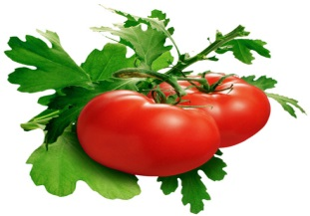 | Italian Cooking classes  LaMiaCucina.com.au Tele: 0432 911 537 Email:Maria@LaMiaCucina.com.au  La Mia Cucina | 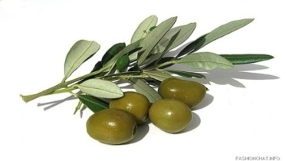
Create your own Italian Pantry
6 week Course where you learn to make the very best of Italian Food

w  e  e  k  1 | Pasta  - Fettuccini,  - Pappardelle  - Spinach & Ricotta Ravioli  - Meat Cannelloni  - Tomato Sauce | W  e  e  k  2 | Various  - 2 types of gnocchi  - Lasagna  - Meat Sauce  - Pasta Sauces | W  e  e  k  3 | Vegetarian  - Capsicums  - Eggplant  - Pepperonata  - Stuffed vegetables  - Frittatas
w  e  e  k  4 | Meat  - Involtini – Pork, Veal &Vegetarian  - Stuffed olives  - Chicken cotolette | W  e  e  k  5 | Dolci  - Zuppa Ingelese  - Tira mi su  - Crostata  - Crostoli  - Biscotti | W  e  e  k  6 | Faciamo una Festa  (Let’s Party)  - Bruschetta toppings  - Antipasto platters.  - Finger Food – sweet and savoury

At La Mia Cucina, classes are designed to give you the skills and knowledge to cook delicious Italian food the tried and true traditional way. Maria and her team will pass on their wealth of cooking skills given to them by their mothers so you can Create your own Italian Pantry

- Learn how to dry, freeze and store the best of Italian Food
- All ingredients provided for these hands-on Classes.
- MAXIMUM OF 12 aspiring Italian Cooks per class
- Every student takes home:
- Folder of Recipes + Pasta making spatula
- Dishes that are made during the Class
C
3 course lunch with wine & coffee is served at every Class Classes are from 9.30 am to 3 pm

$950 per person for 6 weeks course

